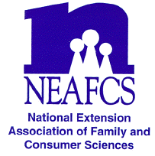
North Carolina Extension Association of Family & Consumer Sciences

The Professional Association of North Carolina Cooperative Extension Family and Consumer Educators

ADA B. DALLA-POZZA PROFESSIONAL DEVELOPMENT ENDOWMENT AWARD APPLICATION

NOTE: Application should be typed, double-spaced, up to three pages in length, with all pages numbered consecutively.

SUBMIT APPLICATION USING THE EXTENSION AWARDS APPLICATION PROCESS EACH YEAR.

PLEASE PRINT OR TYPE

Personal Information:

Name __________________________________________
Current Position ______________________________
Office Address _______________________________________________ County____________________________
City__________________________________________ State __________ Zip _______________________
Office Telephone______________________________ Home Telephone_______________________________
Years of NCEAFCS membership ____________________Years of NEAFCS membership ________________

Date: __________________________ Signature _________________________________________________
Applicant

I have reviewed this application and supplemental information and certify to it and the application or plan.

Date: __________________________ Signature _________________________________________________
Immediate Supervisor

On separate page(s) include the following:
- Overview of Extension Accomplishments (within the past three years)
- Involvement in NCEAFCS and other professional associations
- Future Plans for Professional Development
- Professional development experience planned for use of this award

Due to District Vice President of Awards and Recognition

