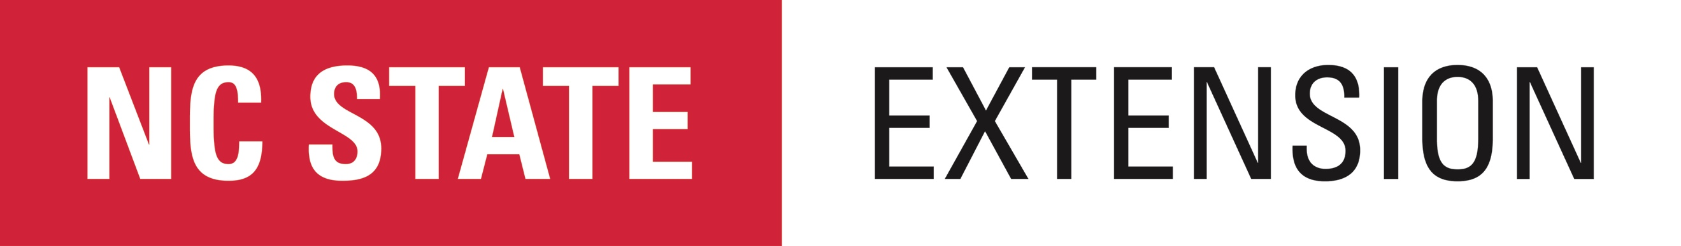

Help us shape the future of Extension programming in your county!

NC State Extension would appreciate your assistance in identifying important issues and opportunities within your local community. Information provided in this survey will be used to help guide and shape the research and educational activities of NC State Extension over the next five years and provide information to advance the current state of knowledge. NC State Extension works in tandem with N.C. A&T State University, as well as federal, state and local governments to deliver education and technology from NC State and NC A&T that enriches the lives, land and economy of North Carolinians. Your participation in this survey is voluntary and confidential. You have the option to not respond to any questions that you choose. Participation or nonparticipation will not impact your relationship with the NC State Extension. Submission of the survey will be interpreted as your informed consent to participate. Any questions about the needs assessment process or survey should be directed to Meredith Weinstein, Ph.D., Evaluation and Accountability Coordinator at meredith_weinstein@ncsu.edu.

SURVEY LINK:

http://go.ncsu.edu/countymanagersurvey

