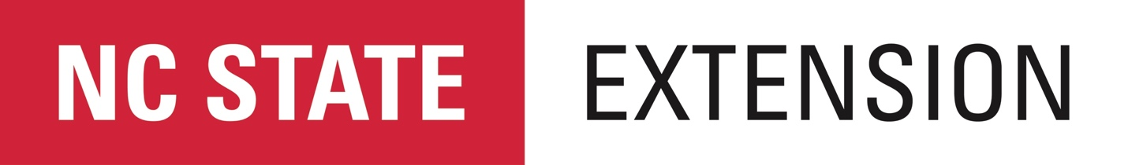

NC State Extension 2017 Needs Assessment
County Commissioner Survey Instructions

During the NC Association of County Commissioners (NCACC) 2017 Annual Conference an invitation will be distributed to each County Commissioner requesting completion of an online survey prioritizing county needs for Extension programs and services.

In addition, the Extension Director will make an announcement during the business meeting requesting completion of the survey.

iPads will be available at the Extension booth to assist County Commissioners with survey completion.

